1. **Which are the top three variables in your model which contribute most towards the probability of a lead getting converted?**

Ans. The top 3 variable that contribute in a lead getting converted are below:-

1. Do Not Email
2. Last Activity
3. Tags
4. **What are the top 3 categorical/dummy variables in the model which should be focused the most on in order to increase the probability of lead conversion?**

**Ans.** Based on the coefficient values from below screenshot, the following are the top three Variables that contribute most towards the probability of a lead getting converted:

1. Tags_Closed by Horizzon
2. Tags_Lost to EINS
3. Tags_Will revert after reading the email

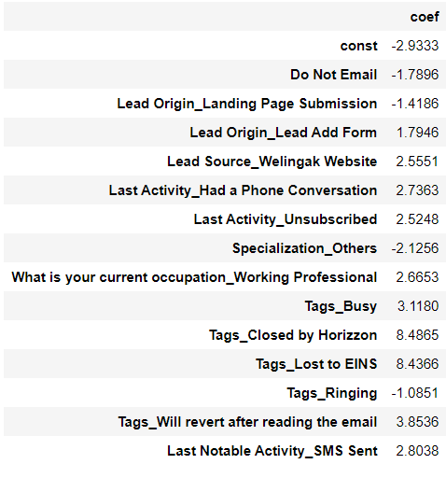

1. **X Education has a period of 2 months every year during which they hire some interns. The sales team, in particular, has around 10 interns allotted to them. So during this phase, they wish to make the lead conversion more aggressive. So they want almost all of the potential leads (i.e. the customers who have been predicted as 1 by the model) to be converted and hence, want to make phone calls to as much of such people as possible. Suggest a good strategy they should employ at this stage.**

Ans. To Utilize this time duration and maximizing the lead conversion, Phone calls should be done to people who have higher Conversion Probability(Lead score more than 38) as predicted by the model. Considering the variable, phone call should be made to people under categories:

1. Tags_Will revert after reading the email
2. Working Professional
3. Last-Notable activity as SMS Sent
4. **Similarly, at times, the company reaches its target for a quarter before the deadline. During this time, the company wants the sales team to focus on some new work as well. So during this time, the company’s aim is to not make phone calls unless it’s extremely necessary, i.e. they want to minimize the rate of useless phone calls. Suggest a strategy they should employ at this stage.**

**Ans.** As the target is already achieved, we have to set the cut off at high value as to get high Specificity which will increase the probability of lead conversion and sales team can focus on them only and unnecessary call number will be significantly low